SyncSharp: Plug & Sync

File Synchronization Software

User Guide V2.0

***12/4/2010***

***Azhar Bin Mohamed Yasin***

***Loh Jianxiong Christopher***

***Hong Lei***

***Guo Jiayuan***

***Tian Shuang***

***Tan Yewkang***

**TABLE OF CONTENTS**

[Part 1: Product Description 4](#_Toc258883231)

[Part 2: Using Syncsharp 4](#_Toc258883232)

[2.1 On First Run 4](#_Toc258883233)

[2.2 Creating New Sync Task 5](#_Toc258883234)

[2.3 Delete Sync Task 6](#_Toc258883235)

[2.3 Task Management Menu 7](#_Toc258883236)

[2.4 Modify Sync Task 8](#_Toc258883237)

[2.5 View Log 13](#_Toc258883238)

[2.6 Import Profile 14](#_Toc258883239)

[2.7 Export Profile 16](#_Toc258883240)

[2.8 Analyze SyncTask 18](#_Toc258883241)

[2.8 PlugSync 20](#_Toc258883242)

[2.9 Configuring Global Settings 21](#_Toc258883243)

[Part 3 Troubleshooting 22](#_Toc258883244)

[3.1 Auto-Play feature Is Not Working 22](#_Toc258883245)

[Part 4 Glossary 24](#_Toc258883246)

# Part 1: Product Description

Syncsharp is developed for users who work with multiple computers and need to synchronize files that reside in different computers through an immediate device such as a USB drive. It is a Windows based application that allows users to sync files between multiple computers through an immediate device with no installation required. The file synchronization process is streamlined through a list of pre-determined user preferences.

# Part 2: Using Syncsharp

## 2.1 On First Run

On first run, user will need to run SyncSharp manually by double clicking on the program executable. Subsequently, the program will launch automatically upon USB device plug-in. Upon double clicking the executable, the following main window will pop up.

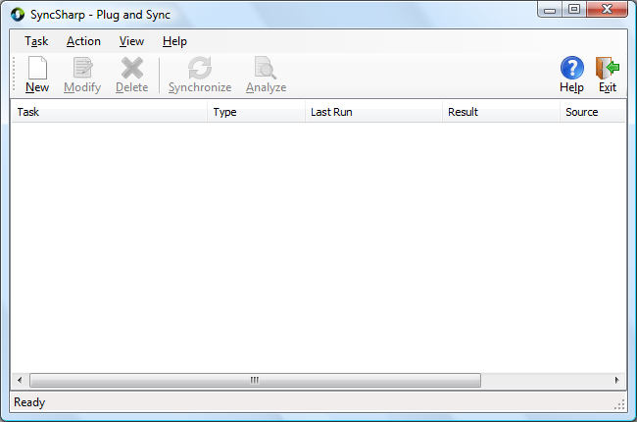

## 2.2 Creating New Sync Task

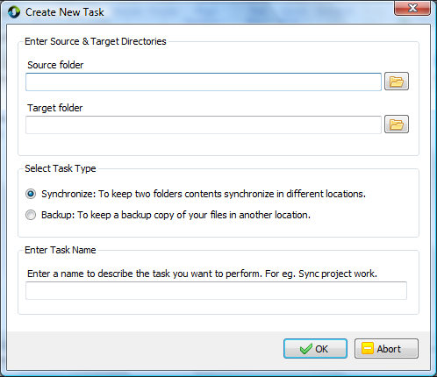

*Step 1:* Click on ***New***, the ***Create New Task*** window will show up.

*Step 2:* Click on the browse icon  to select the two source and target folders. (or user can enter the directory into the text box. In addition, user can make use of environment variables like %HOMEPATH% in the path name.)

*Step 3:* ***Select Task Type***.

Synchronize – To keep source and target folders contents in sync.

Backup – To backup files in source folder to target folder.

*Step 4:* ***Enter Task Name***. Specify the name of this Sync Task.

*Step 5:* Click on ***OK*** to finish the wizard.

Alternatively, users can drag and drop folders into the main window and **Create Task Form** will be displayed with the folders input.

## 2.3 Delete Sync Task

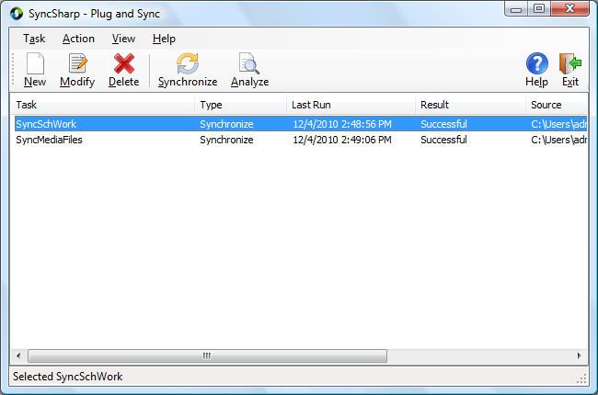

*Step 1:* Choose the Sync Task you want to delete.

*Step 2:* Click ***Delete***.

*Step 3:* A confirmation dialog will pop up, click *Yes* to confirm deletion or click *No* to cancel.

## 2.3 Task Management Menu

On the main window, right clicking on any task will bring up a ***context menu*** (as shown below). User can modify, delete, rename, synchronize, view log file or create new task using the menu.

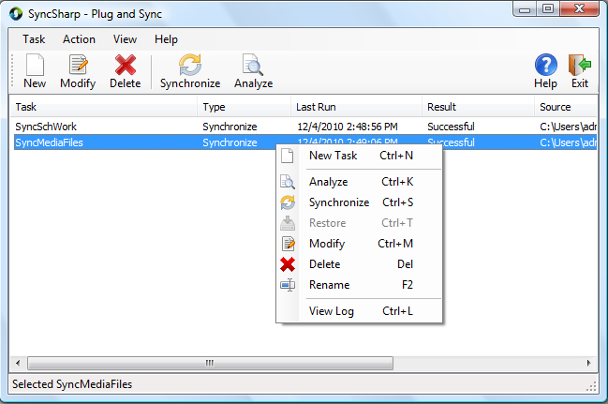

|  |  |
| --- | --- |
|  | **New Task**: Create a New Task  **Analyze**: Preview a synchronization task  **Synchronize**: Sync the selected task  **Restore**: Restore a previously backup task  **Modify**: Configure task settings  **Delete**: Remove the selected task from profile  **Rename**: Rename the selected task  **View Log**: Display the log file of the task |

## 2.4 Modify Sync Task

*Step 1:* Select a task and click ***Modify*** (or just double-click on the task). The ***Task Setup*** window which consists of the following tab pages will pop up.

* ***General*** – Display general information.
* ***Folder Pair*** – Modify folder pairs.
* ***Filter*** – Include/exclude file/folders in sync action.
* ***Advanced*** – Advanced syncing options.

***General*** Tab

User can rename the task and change the task type in this tab page.

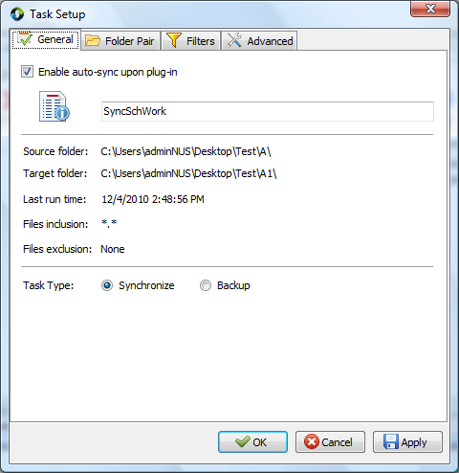

***Enable auto-sync upon plug-in*** – With this option checked, task will be synchronized automatically when the program is executed on next run.

***Folder Pair*** Tab

User can change the source and target directories in this tab page.

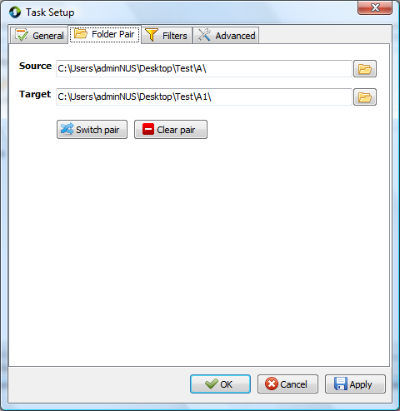

***Switch pair*** – Switch the path of “Source” and “Target”

***Clear pair*** – Delete the path of “Source” and “Target”

***Filters*** Tab

User can set files and folders filters in this tab page.

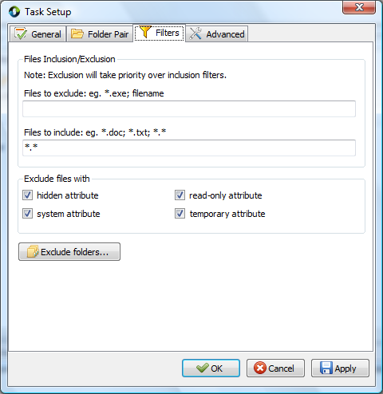

***File Inclusion/Exclusion*** - Users are allowed to include/exclude files in “source” and “target” directory in the sync process. Filtering is based on file name or extension, (For e.g., to exclude all files with extension ‘***.doc***’, enter ‘***\*.doc***’ in ‘***Files to exclude***’ textbox). Users is allowed to set multiple filtering criteria separated by ‘***;***’.

Filtering of subfolders is achieved by using the ***Exclude folder…*** option***.***

***Exclude files with*** – Filtering can also be achieved based files/folders attributes. The default files to exclude are files with ‘***system***’ and ‘***temporary***’ attribute.

***Exclude folders…*** will list out all sub folders in “Source” and “Target”. User is able to exclude sub-folders by checking the respective folders. (Below is a screenshot of its window).

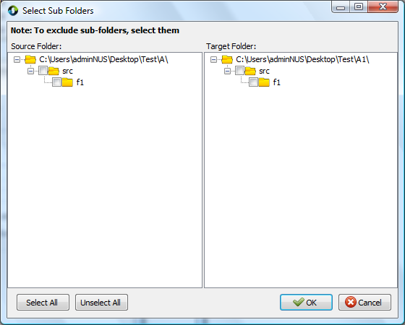

***Advanced*** Tab

User can configure files conflict settings in this tab page.

**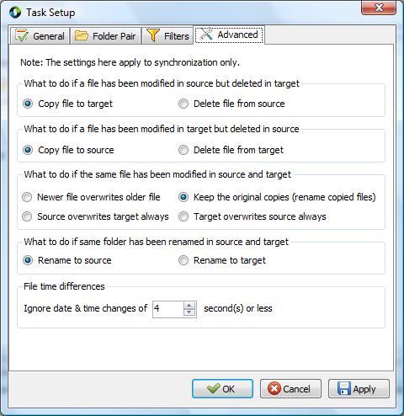**

***File time differences*** – While comparing two files or folders, if the difference in last-modified-time is less than or equals to the pre-set value. These files or folders are considered to be with the same modification time.

## 2.5 View Log

***View Log*** provides a summary of last synchronization to user. File operations like copy/delete/move are recorded in a log file. A sample log file is shown below.

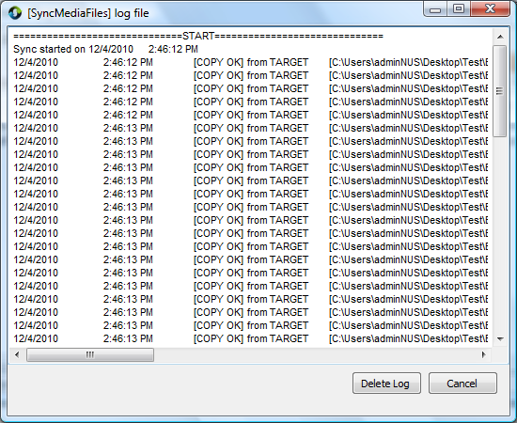

***Cancel:*** Close the View Log window

***Delete Log:*** Delete the task’s log file from disk

## 2.6 Import Profile

*Step 1*: On the main menu, click ***Task***

*Step 2*: Click ***Import Profile …*** or simply use ***Ctrl + I***

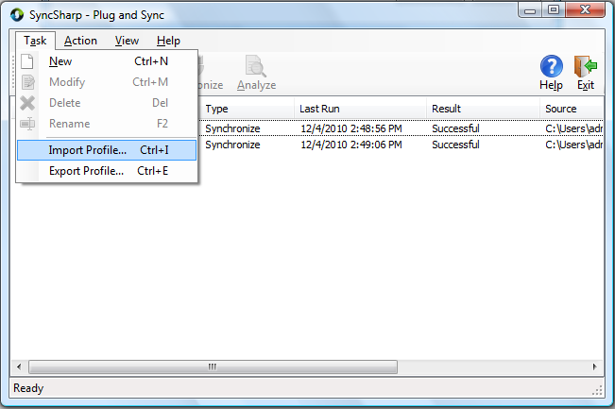

*Step 3*: Specify which Profile to import.

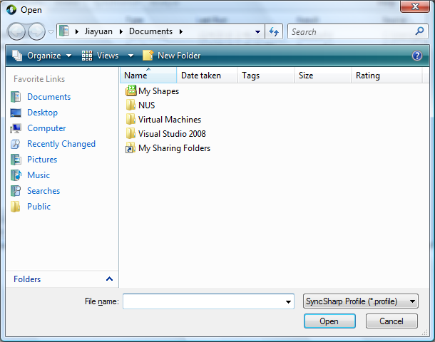

## 2.7 Export Profile

*Step1*: On the main menu, click ***Task***

*Step 2*: Click ***Export Profile …*** or simply use ***Ctrl + E***

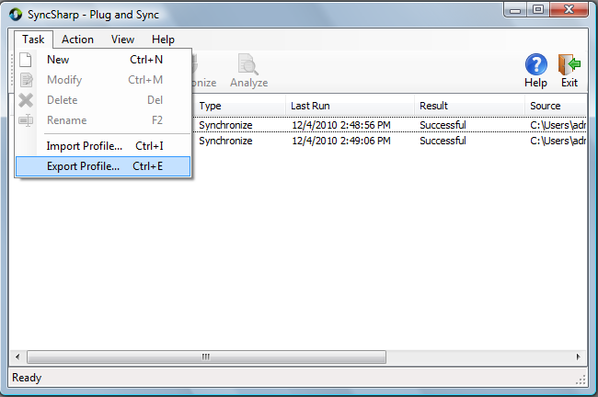

*Step 3*: Specify the location you want the Profile to be saved.

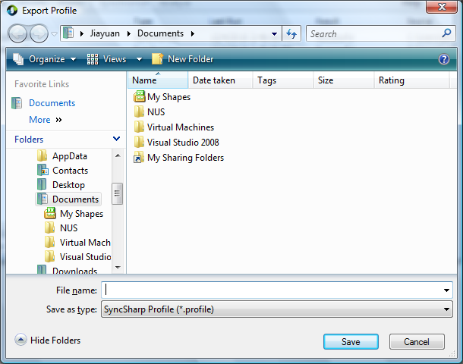

## 2.8 Analyze SyncTask

User can analyze a **synchronize task** by simply clicking on the Analyze button on the main window or enter ***Ctrl+K.*** The following window will be displayed when Analyze button is clicked.

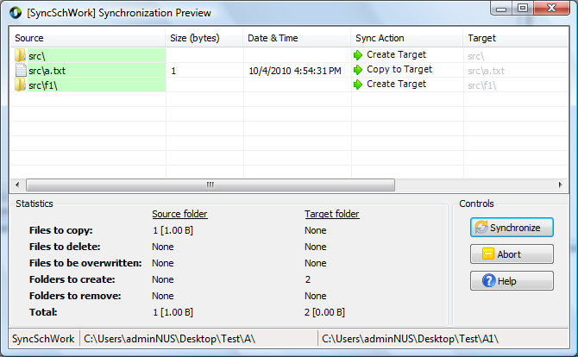

The following table list out the possible icons that could be displayed in the **Sync Action** column and its description.

|  |  |
| --- | --- |
| Icon | Description |
| C:\Users\adminNUS\Desktop\SyncSharp V1.1\Project Icons\left_copy.png | Copy file to source/Create Target folder |
| C:\Users\adminNUS\Desktop\SyncSharp V1.1\Project Icons\right_copy.png | Copy file to target/Create Source folder |
| C:\Users\adminNUS\Desktop\SyncSharp V1.1\Project Icons\KeepBoth_small.png | Keep both files in source & target folders |
| C:\Users\adminNUS\Desktop\SyncSharp V1.1\Project Icons\delete_small.png | Delete both files/folders |
| C:\Users\adminNUS\Desktop\SyncSharp V1.1\Project Icons\delete_left.png | Delete source file/folder |
| C:\Users\adminNUS\Desktop\SyncSharp V1.1\Project Icons\delete_right.png | Delete target file/folder |
| C:\Users\adminNUS\Desktop\SyncSharp V1.1\Project Icons\rename_small.png | Rename source/target file |

Moreover, user can right-click on one of the item to access a list of commands as show in the following screen shot

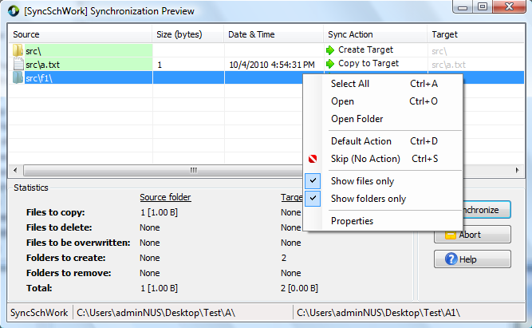

|  |  |
| --- | --- |
|  | **Select All**: Select all items in list  **Open**: Open the selected item  **Open folder**: Open the item’s parent folder  **Default Action**: Change sync action to  **Skip (No Action)**: Exclude the selected item from synchronization  **Show files only**: Display files only  **Show folders only**: Display folders only  **Properties**: Display info about the selected item |

User can click on  button to proceed with synchronization or click  button to return to main window.

## 2.8 PlugSync

After user has setup tasks (with auto-sync enabled) in Syncsharp, **PlugSync** window (as shown below) will be displayed when the program is launched. It will start to count down for 5 seconds (default) before synchronizing all tasks listed in the window.

User can return back to main window by clicking on the  button. Moreover, user can re-order the tasks to be synced by clicking the up  and down buttons. User can also remove  a task from the window if it is not synchronized yet.

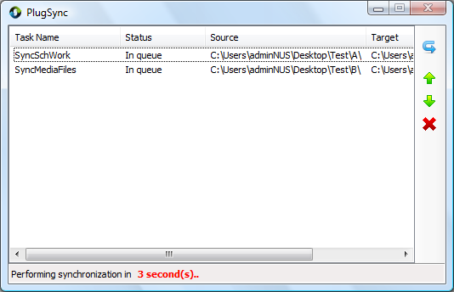

## 2.9 Configuring Global Settings

*Step1*: On the main menu, click ***View***

*Step 2*: Click on ***Options …***, the ***Global Settings*** window shown as below will pop up

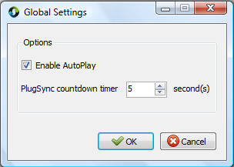

*Step 3*: Use the up and down arrow to change the default countdown timer. (Sync will start right away if the timer was set to 0.)

***Enable AutoPlay.*** If checked, an ***autorun.inf*** will be created on the external storage device to auto launch SyncSharp upon plug in to PC.

# Part 3 Troubleshooting

## 3.1 Auto-Play feature Is Not Working

On some Windows machines, ***auto play*** feature may be disabled. So in order to fully automate the synchronization process using ***PlugSync***, user may need to modify the ***auto play*** settings. This guide will walk you through step by step on how to change the ‘auto play’ settings.

On Windows Vista:

*Step 1*: Click on ***Start*** 🡪 In the search box, type in ***autoplay***

*Step 2*: Choose the first returned result, which looks like



*Step 3*: Click on the icon, the following window will pop up.

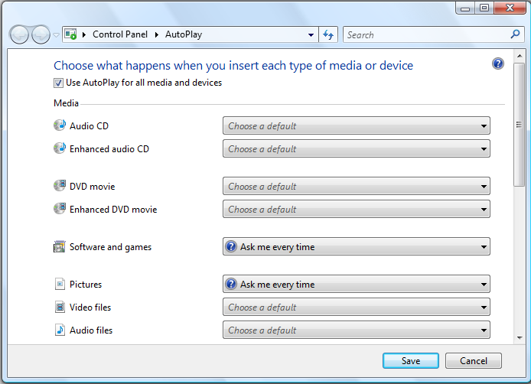

*Step 4*: Check the box ***Use AutoPlay for all media and devices***

*Step 5*: In the drop-down list for ***Software and games***, choose ***Ask me every time***.

*Step 6*: Click on ‘***Save***’ to save the setting.

*Step 7*: The next time user plug in his external storage device, system will prompt user for actions. A window looks like the following will show. Check the box ‘***Always do this for software and games:***’ and click on ‘***Run SyncSharp***’ to activate the program. By doing this, this action is saved on the machine, and the PlugSync feature will function properly.

**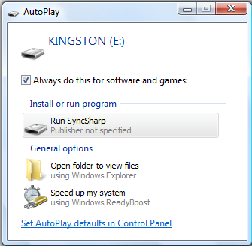**

# Part 4 Glossary

|  |  |
| --- | --- |
| Term | Definition |
| SyncSharp | Name of our sync tool |
| SyncTask | Configuration file that contains source and target directory information to be synchronized |
| SyncProfile | Contains list of SyncTasks for a Particular PC/Laptop |
| FileUnit | Abstract representation of a file or folder, contains information such as name, size, hash code, last modified date, etc. |
| PlugSync | A feature of our program. Program will synchronize all tasks automatically when the USB device is plugged into a computer. Upon execution, the program will count down for 5 seconds waiting for user interruption. If there is no interruption, the program will proceed to synchronize all the tasks listed in the window. |
| 1 way sync | Update destination directory to have the same content as source directory |
| 2 ways sync | Update source and destination directories to have the same state |
| Report/Logger | Log file that records the operations perform in the synchronization process |
| Target | The destination directory to be sync or compared |
| Detector | The sub-system that detect changes of the source or destination directory |
| Reconciler | The sub-system that resolves conflicts between the source & destination directories |
| TaskSettings | Contains configuration settings made for each SyncTask |